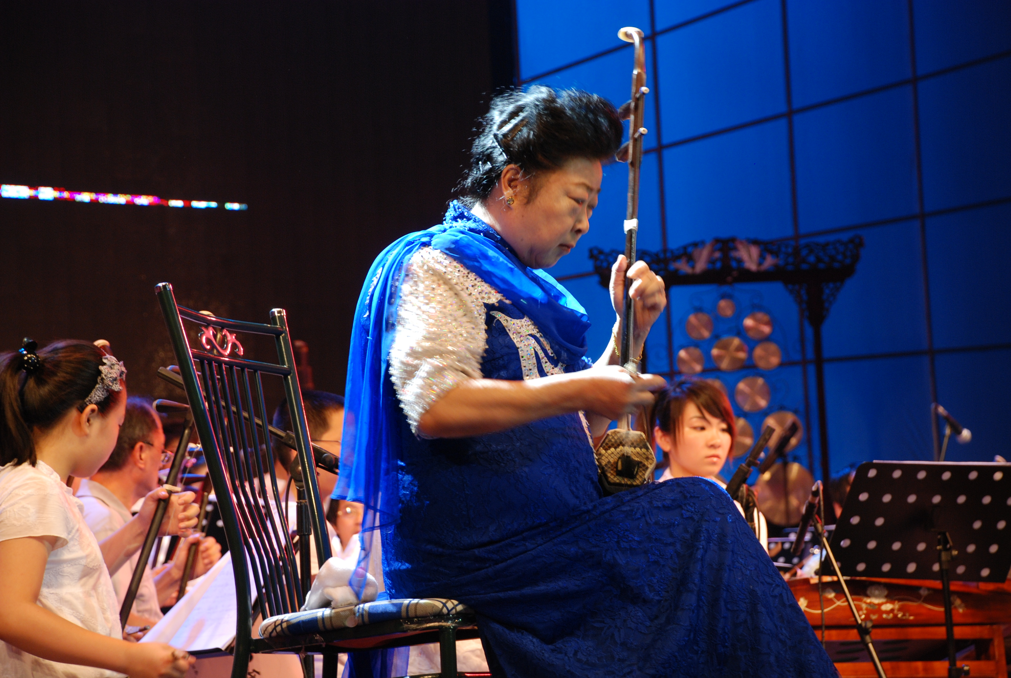
http://www.gfzx.com/intro/news/info_show.asp?id=00001956
2008.7.赴餘姚龙山剧院出席首届二胡大师班汇报演出
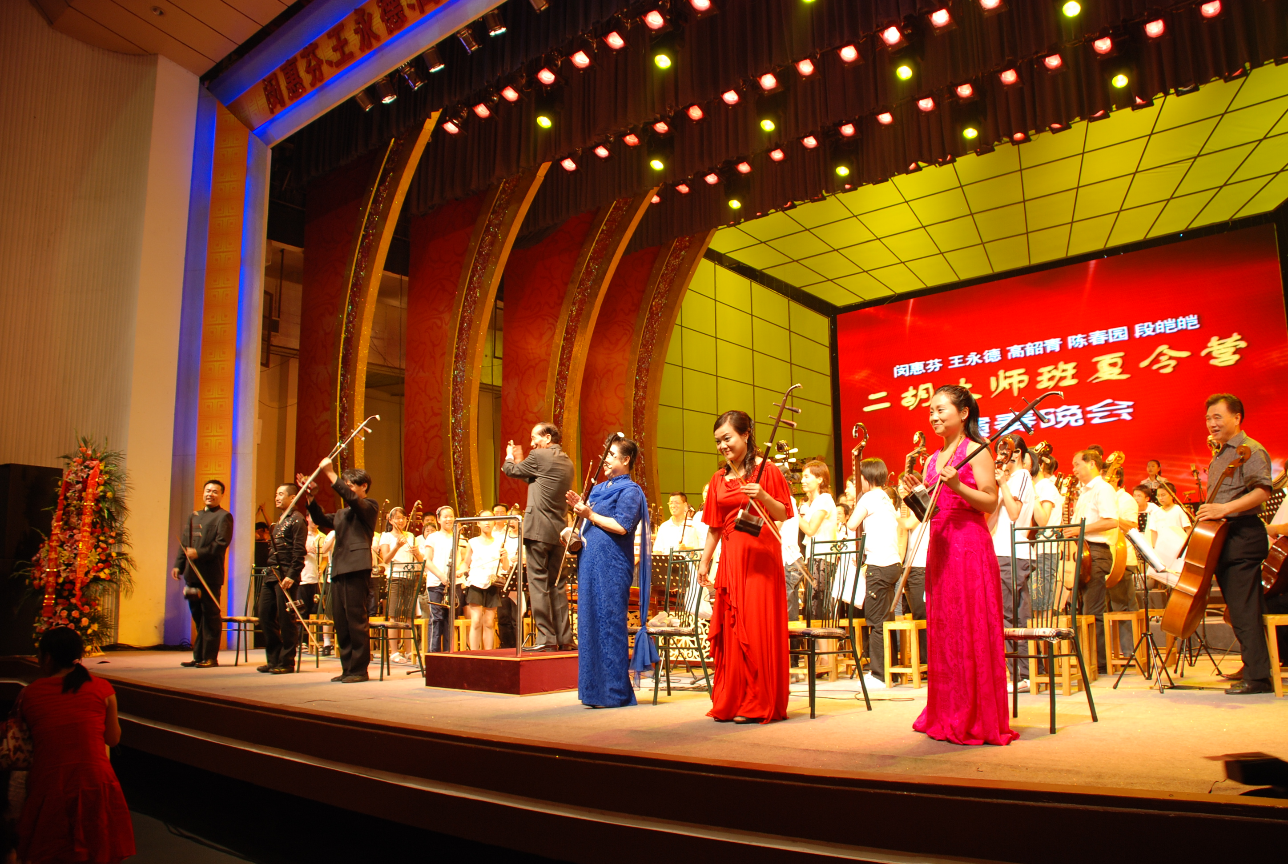
http://www.gfzx.com/resource/xxgc01%5C00001956_p0.JPG

